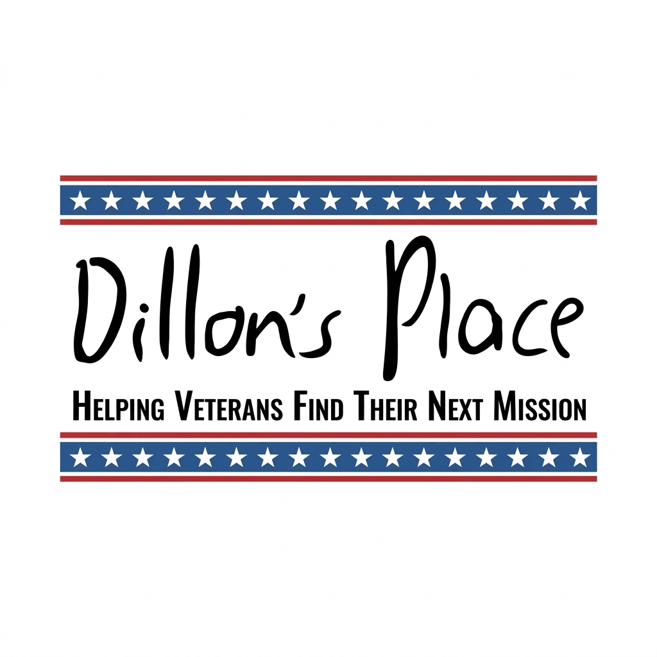
Dillon's Place Race/Walk & Half Murph
Annual Charity Event Sponsorship Form
Thank you for your interest in partnering with Dillon's Place Foundation. Your generous sponsorship directly supports our mission and community programs. Please review our updated opportunities below and select your preferred level.
🏢 SPONSOR INFORMATION
Company / Organization Name: __________________________________________________
Contact Person Name: _________________________________________________________
Billing Address: ______________________________________________________________
Contact Phone: ___________________________ Contact Email: _______________________
Website / Social Handle: _______________________________________________________
🏆 SPONSORSHIP LEVELS
[ ] Blue Ribbon Sponsor — $3,500
• Presenting Sponsor status at the Half Murph Challenge
• Dedicated event signage
• Logo on all promotional marketing materials
• Logo featured prominently on event website
• Dedicated recognition posts across social media
[ ] White Stars Sponsor — $2,200
• Dedicated event signage at the Half Murph Challenge
• Logo on all promotional marketing materials
• Logo featured on event website
• Recognition posts across social media
[ ] Red Stars Sponsor — $1,000
• Logo on all promotional marketing materials
• Logo featured on event website
• Recognition posts across social media
[ ] Silver Star Sponsor — $500
• Text or logo listing on event website
• Recognition posts across social media
💳 PAYMENT INFORMATION
[ ] Check Enclosed (Please make checks payable to: Dillon's Place Foundation)
[ ] Credit Card (Pay online at [Website URL] or complete details below)
Card Number: ___________________________ Exp. Date: _______ CVV: _____ Zip: ________
[ ] Invoice Request (Payment due by: [Date])
Scan QR Code to make your donation:

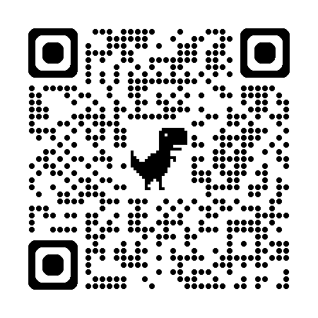

📝 AGREEMENT & LOGO SUBMISSION
Please email your high-resolution logo (PNG or vector format) to angela@dillonsplace.org by October 26, 2026 to guarantee placement on physical signs and marketing materials.

Authorized Signature: ___________________________ Date: ___________________________
Please return this completed form and payment to:
Dillon's Place Foundation | 2473 Seton Dr, Avon, OH 44011 | angela@dillonsplace.org

